**Exercise 1: Create a Jupyter Notebook**

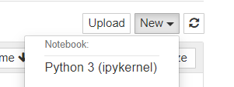

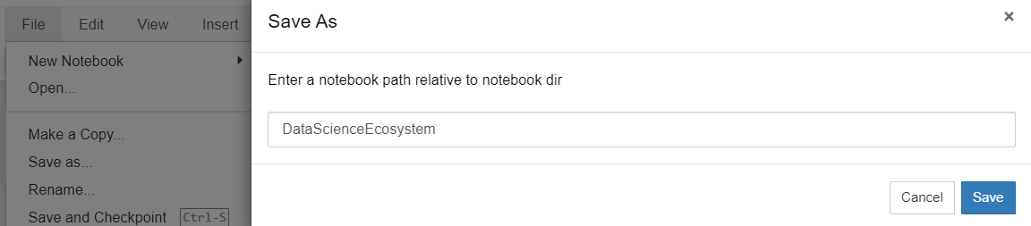



**Exercise 2: Create markdown cell with title of the notebook**

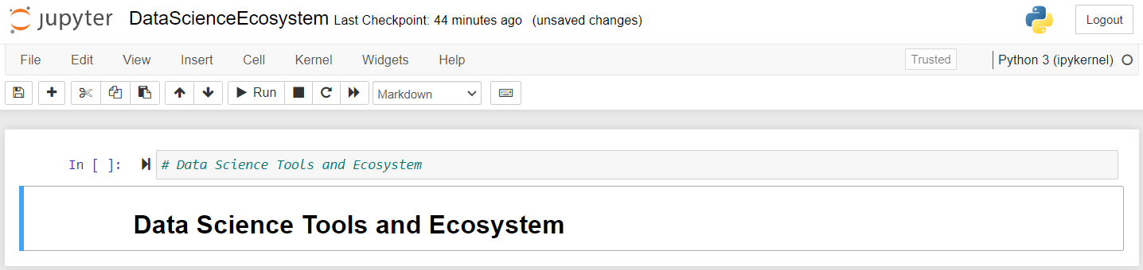

**Exercise 3 - Create a markdown cell for an introduction**

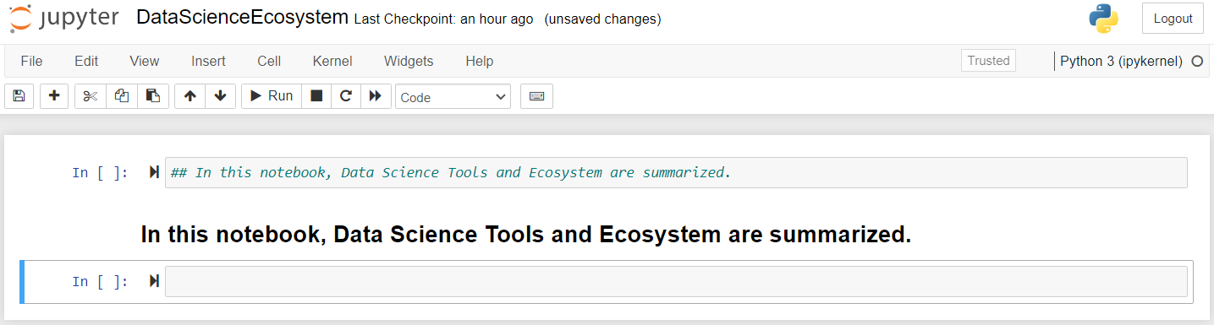

**Exercise 4 - Create a markdown cell to list data science languages**

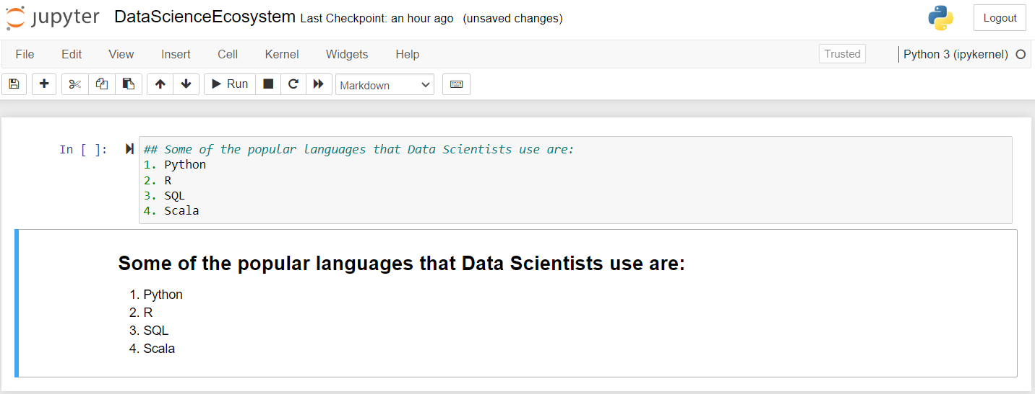

**Exercise 5 - Create a markdown cell to list data science libraries**

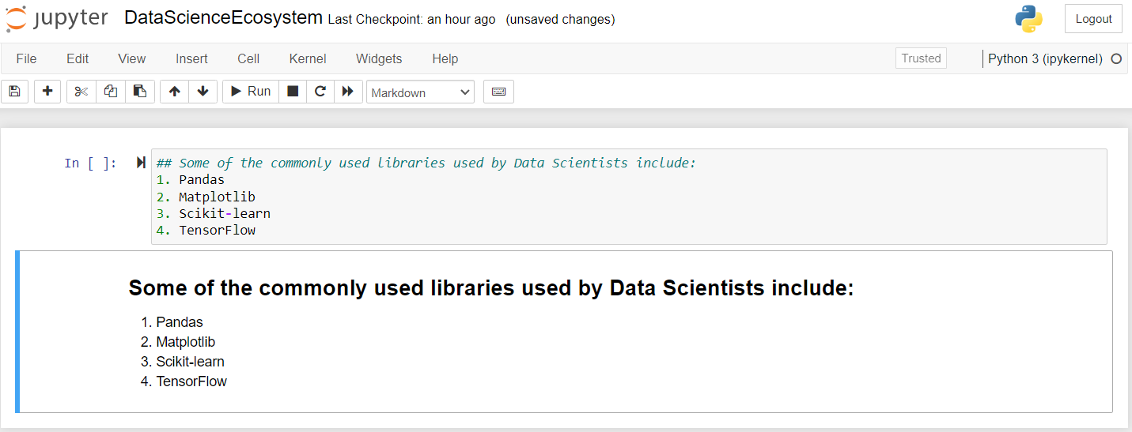

**Exercise 6 - Create a markdown cell with a table of Data Science tools**

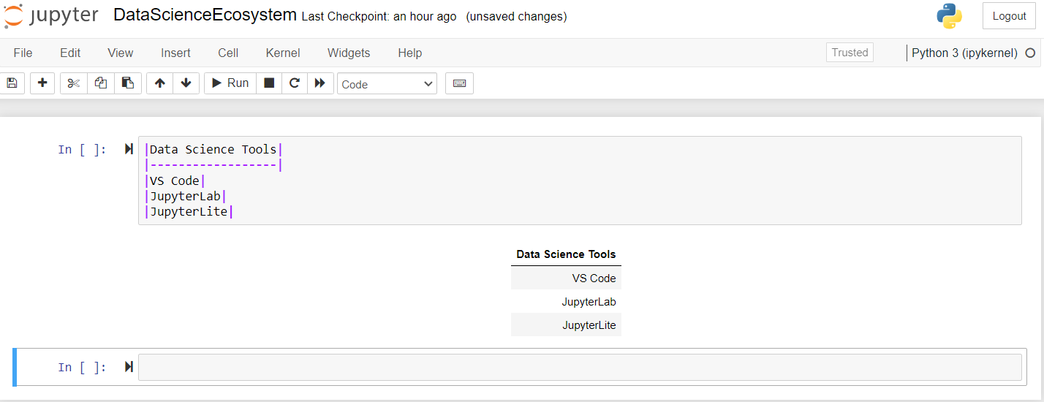

**Exercise 7 - Create a markdown cell introducing arithmetic expression examples**

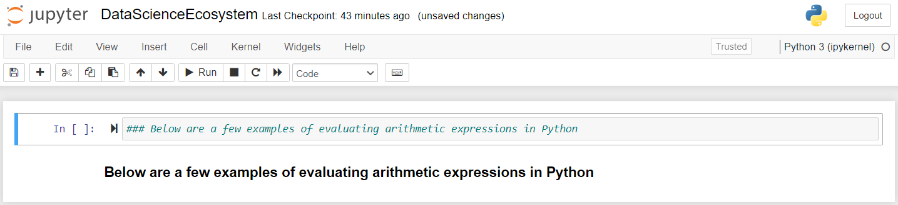

**Exercise 8 - Create a code cell to multiply and add numbers**

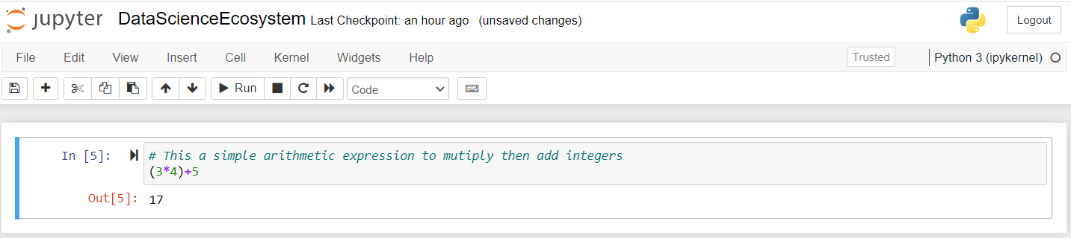

**Exercise 9 - Create a code cell to convert minutes to hours**

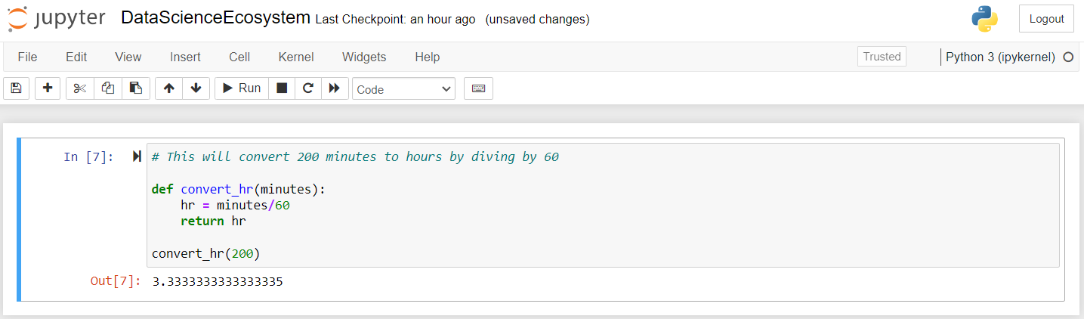

**Exercise 10 - Insert a markdown cell to list Objectives**

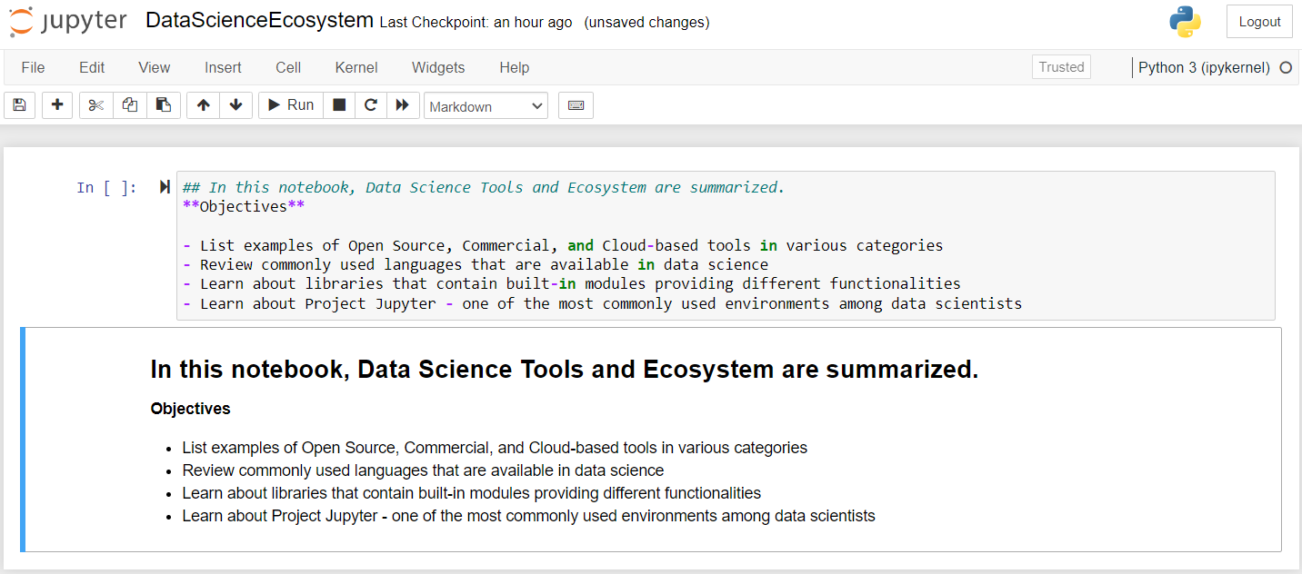

**Exercise 11 - Create a markdown cell to indicate the Author's name**

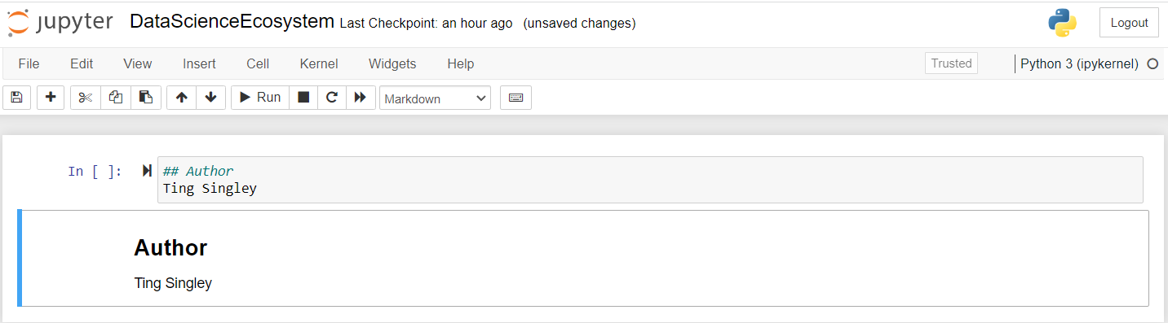

**Exercise 13 -Take a screenshot of the first page of the notebook**

